Pnc hw1

Name:

bruceSz

Steps:

1 > start rviz:

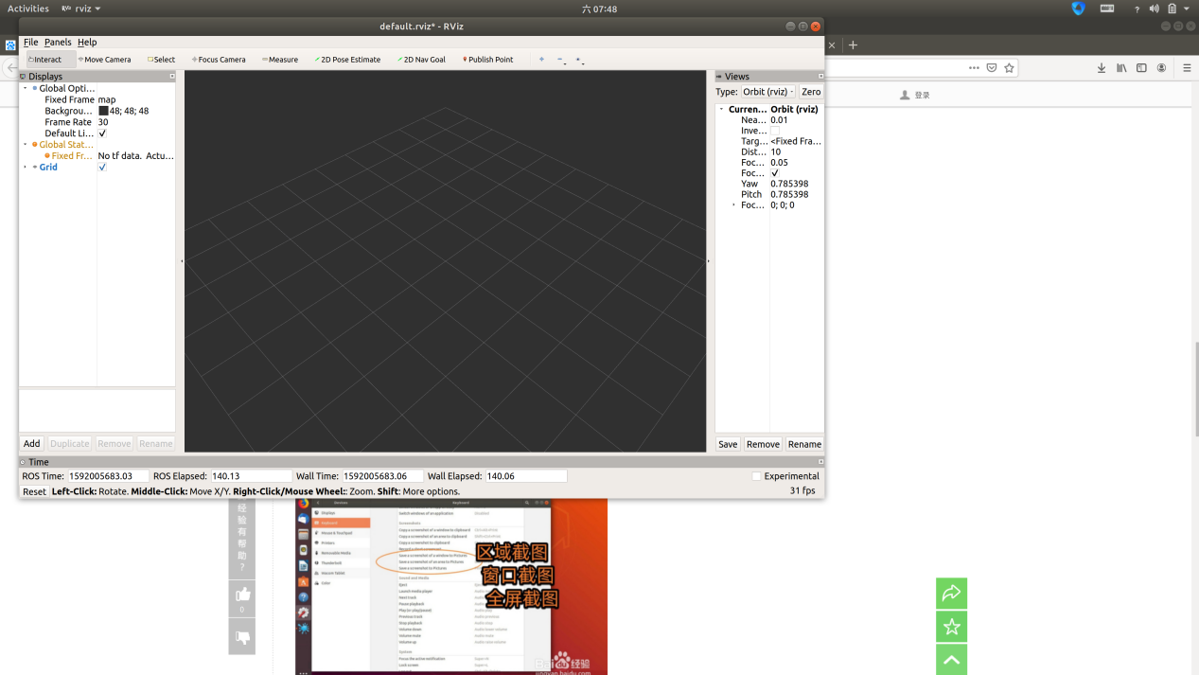

1. Add demo.rviz configuration

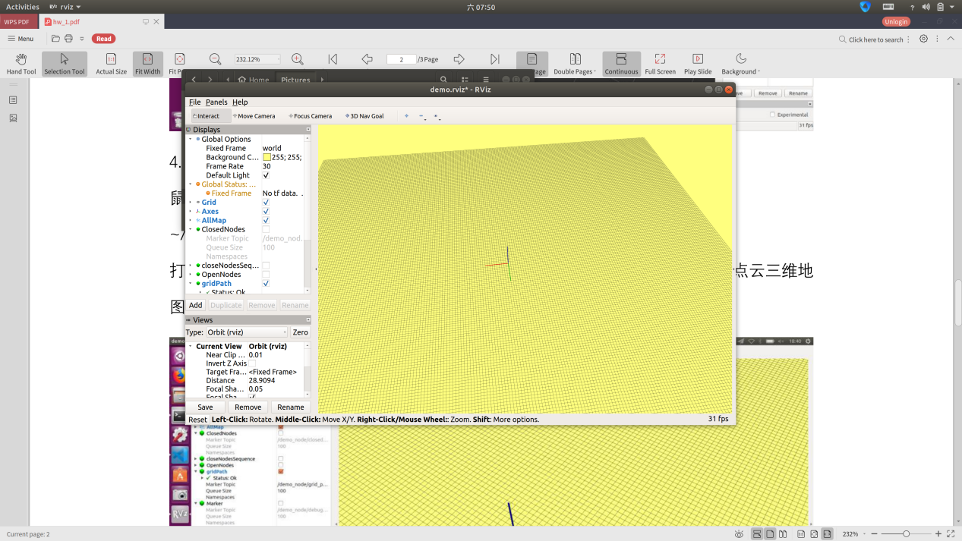

1. Start grid_searcher with demo.launch

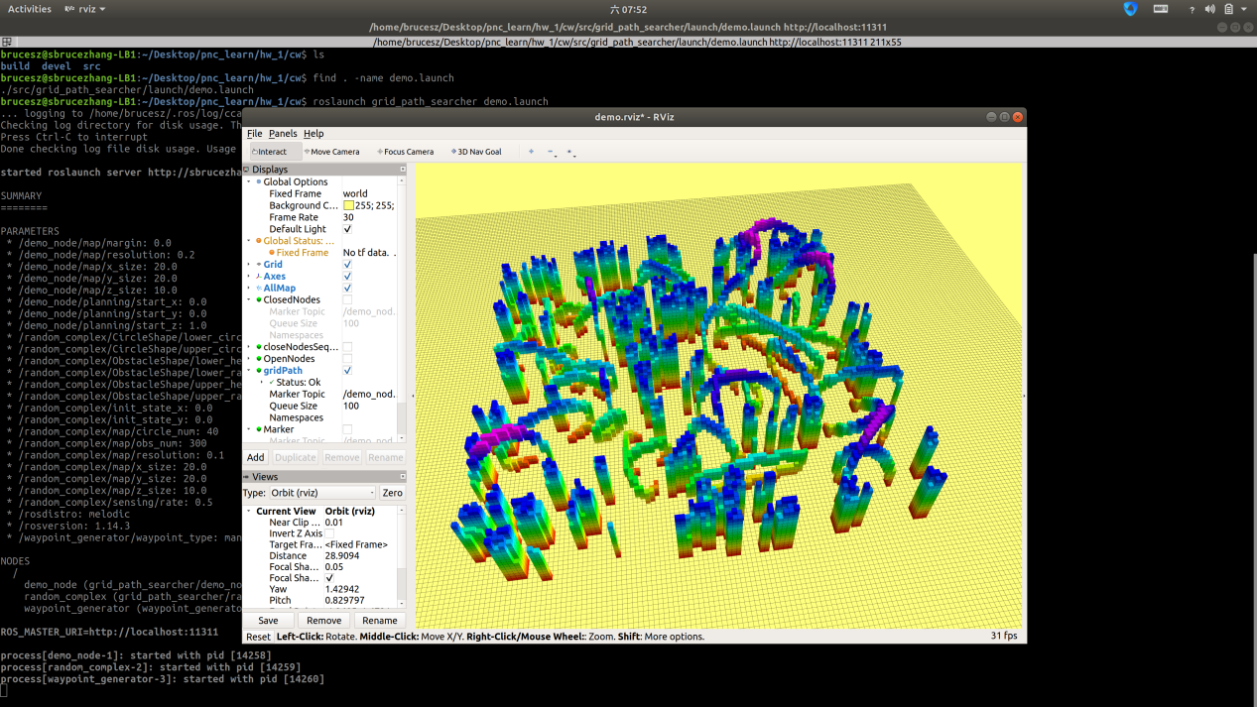

Done.